**DAILY ONLINE ACTIVITIES SUMMARY**

|  |  |  |  |
| --- | --- | --- | --- |
| **Date:** | 30/05/2020 | **Name:** | Krishnitha |
| **Sem & Sec** | 4th sem, A Section | **USN:** | 4AL18CS039 |
| **Online Test Summary** | | | |
| **Subject** | 1) Data Communication  2) Complex Analysis, Probability and Statistical Methods | | |
| **Max. Marks** | 1) 30  2) 30 | **Score** | 1) 26  2) 30 |
| **Certification Course Summary** | | | |
| **Course** | Trailhead Basics | | |
| **Certificate Provider** | Sales force | **Duration:** | 5hrs |
| **Coding Challenges** | | | |
| **Problem Statement:**  Write a C Program to count Uppercase, Lowercase, special character and numeric values for a given String | | | |
| **Status:** Executed | | | |
| **Uploaded the report in GitHub** | | YES | |
| **If yes Repository name** | | <https://github.com/krishnitha/C-coding> | |
| **Uploaded the report in slack** | | YES | |

Online Test Details:

Today we had assessment in the subject Data Communication. It was based on third and fourth module of this subject. There were total 30 number of questions of ONE mark each, out of which I scored 26.

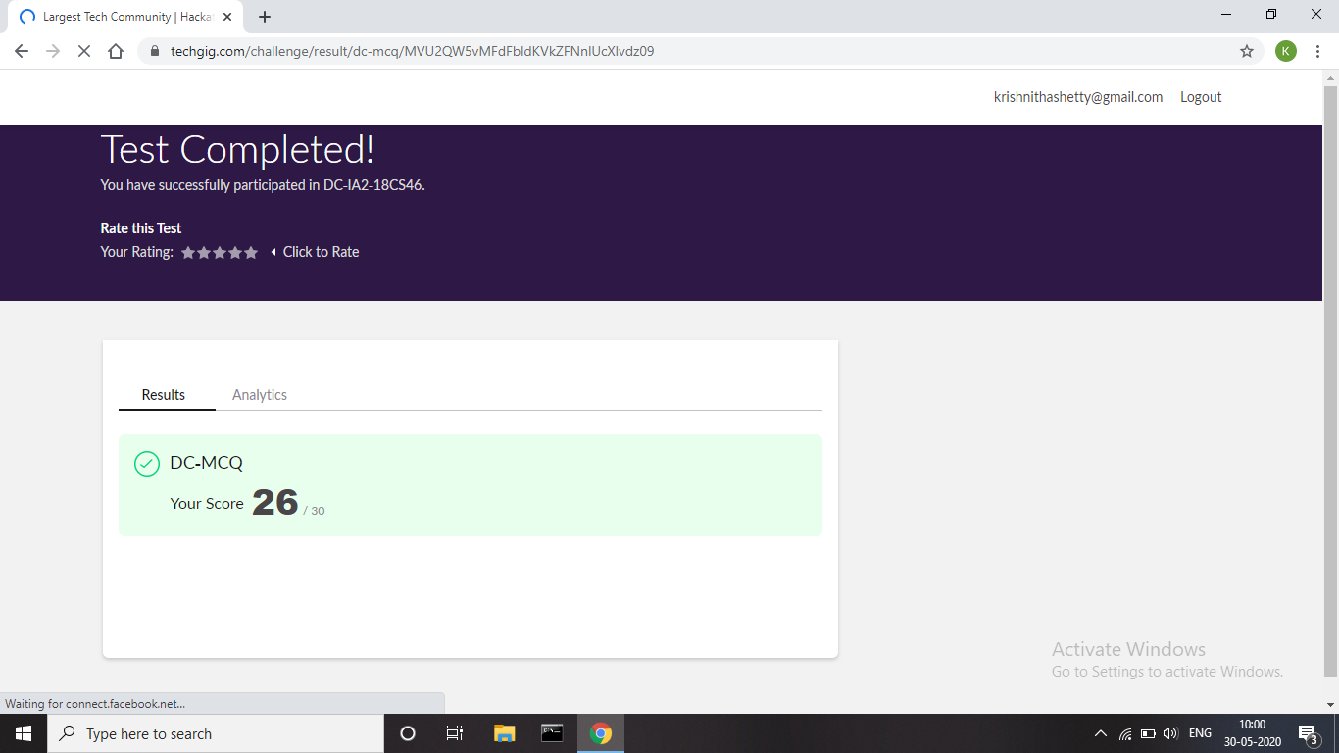

And also, we had final assessment of the subject Complex Analysis, Probability and Statistical Methods. The questions were MCQ type. The test was comprised of 10 questions of 1 mark each, out of which I scored 10. And 10 questions of 2 marks each. Out of which I scored 20

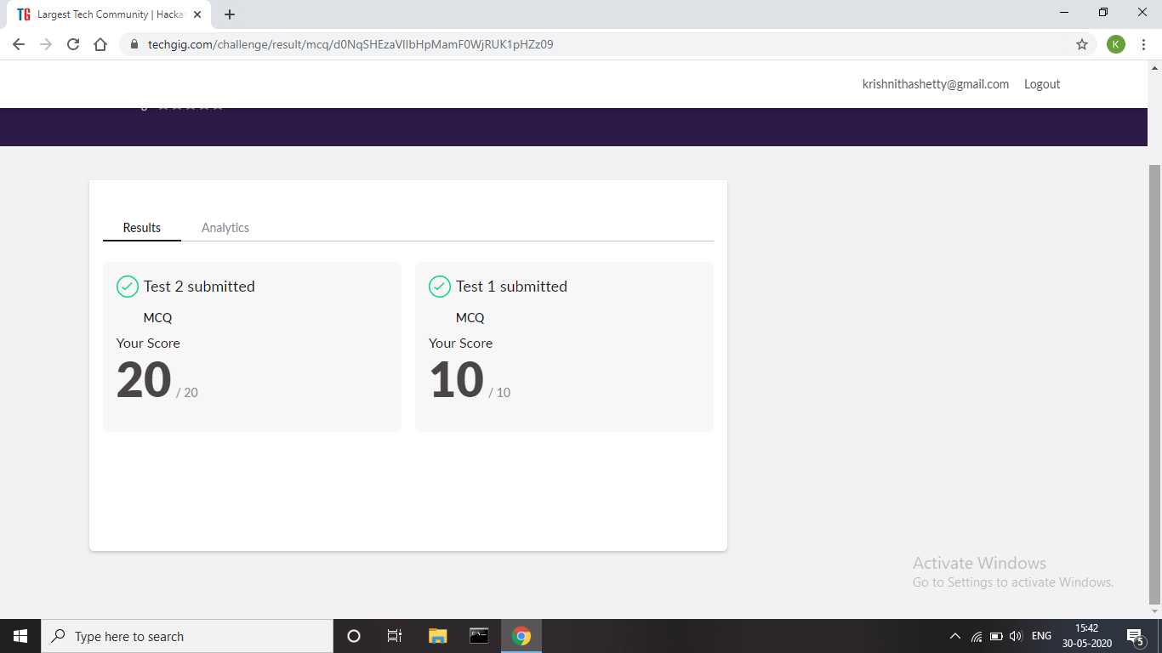

Certification Course Details:

Today I have done the Course named Trailhead Basics by Sales Force. Today I have learnt how to create Record Fields, Custom objects and labels.

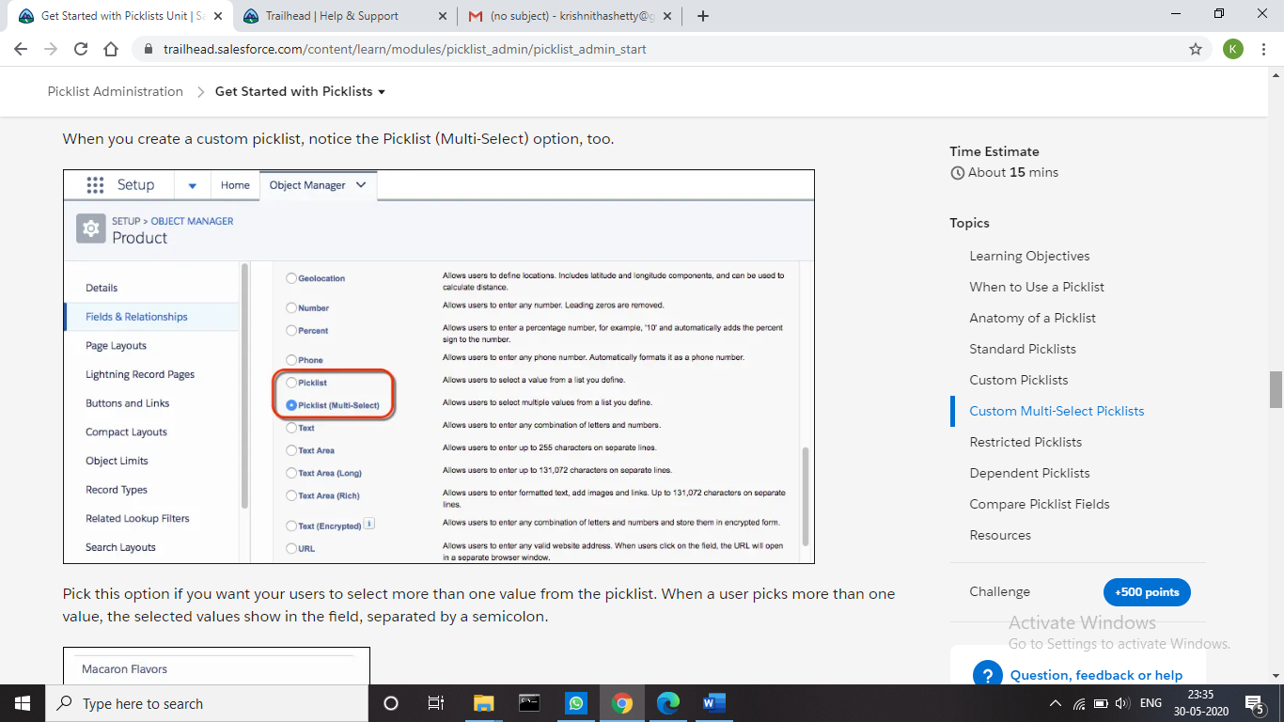

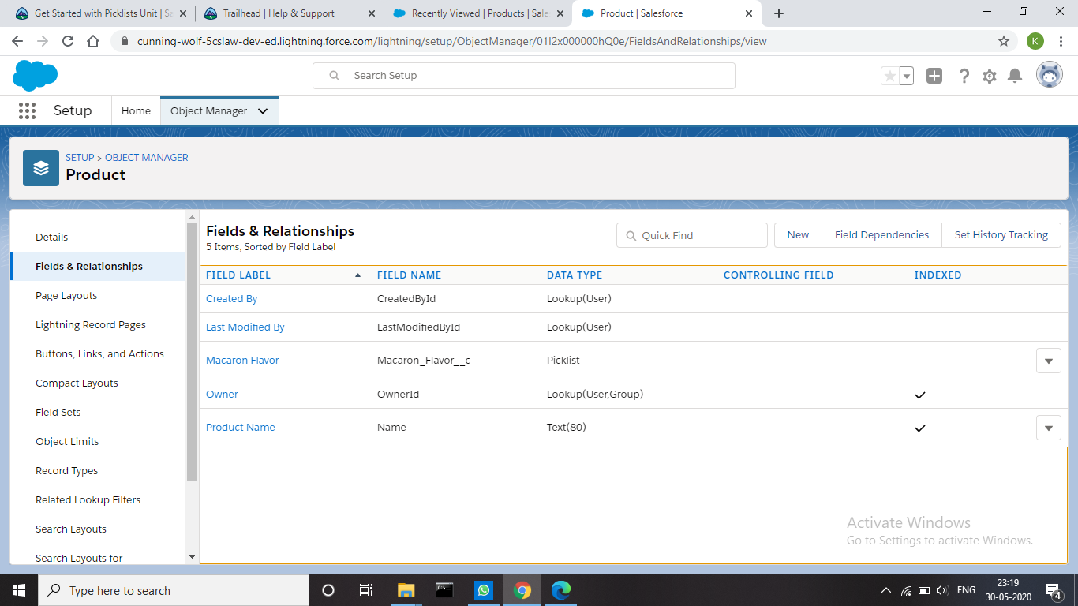

Coding Challenges Details:

Problem 1: Write a C Program to count Uppercase, Lowercase, special character and numeric values for a given String Input: Read a String (combination of character, numeric, special character) from keyboard.

**Ex:** #HaaGs01fOr@haaks07

**Output:**

Upper case letters: 5

Lower case letters: 8

Numbers: 4

Special Characters: 2

**Solution:** Uploaded it in GitHub

